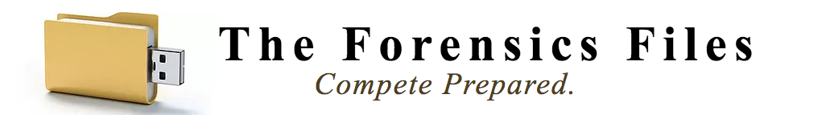

Jan. 5, 2017

Sole-Source Provider Letter for the Current School Year

Dear District Administrator(s):

This letter certifies that The Forensics Files, LLC, (TFF) based out of Round Rock, Texas, is the sole developer and sole source vender for the following product lines:

- The Forensics Files Poster Sets
- The LD File (including TFF Position Files)
- The PF File
- The CX Hybrid File System
- The Forensics Files Textbooks & Workbooks
- The Forensics Files PowerPoints

TFF holds the rights to set pricing, make changes to products, distribute and advertise the aforementioned products. If you have any questions or require additional information, please contact us at:

The Forensics Files, LLC
PO Box #895
Round Rock, TX, 78680
webmaster @theforensicsfiles.com

Sincerely,

/s/ Michael Ritter, Member
The Forensics Files, LLC

